**Practical No. 04**

**Aim:** Implement Bit and Byte Stuffing method of the data link layer.

### Byte Stuffing Mechanism

If the pattern of the flag byte is present in the message byte sequence, there should be a strategy so that the receiver does not consider the pattern as the end of the frame. Here, a special byte called the escape character (ESC) is stuffed before every byte in the message with the same pattern as the flag byte. If the ESC sequence is found in the message byte, then another ESC byte is stuffed before it.

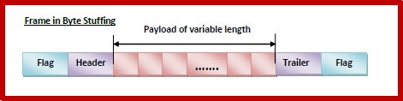

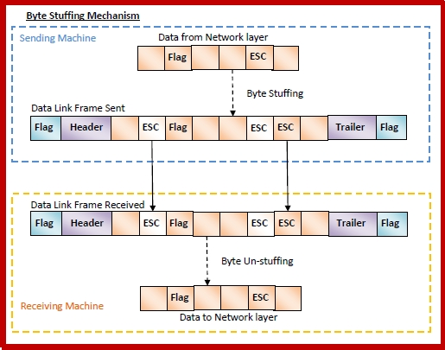

### Bit Stuffing Mechanism

Here, the delimiting flag sequence generally contains six or more consecutive 1s. Most protocols use the 8-bit pattern 01111110 as flag. In order to differentiate the message from the flag in case of same sequence, a single bit is stuffed in the message. Whenever a 0 bit is followed by five consecutive 1bits in the message, an extra 0 bit is stuffed at the end of the five 1s. When the receiver receives the message, it removes the stuffed 0s after each sequence of five 1s. The un-stuffed message is then sent to the upper layers.

